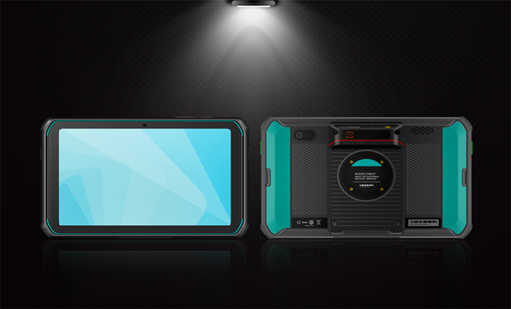
SF817
Android Industrial Tablet
8.0-inch HD full screen·High speed Octa- core·Android 13.0·
Barcode scanning
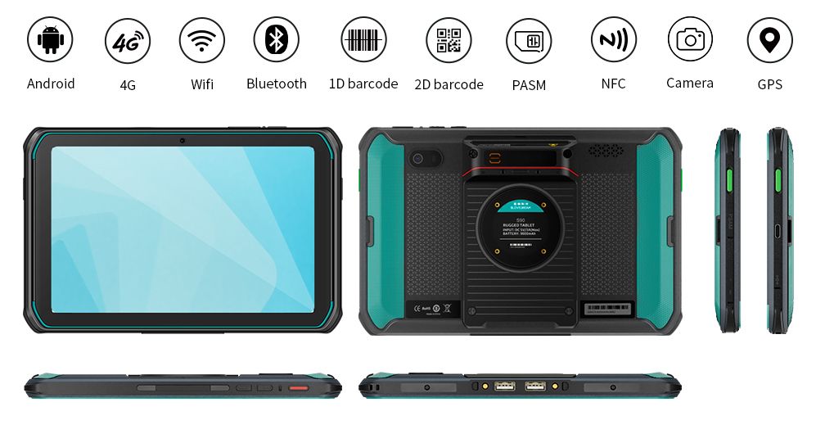

Camera（Standard）
Rear camera | 13MP color camera/20MP color  camera(Optional)  Support auto focus,Flash, Anti-shake, Macro shooting
Front camera | 5MP color camera
UHF (Optional)
Frequency | 865-868 MHz((EHR)
 | 902-928 MHz (USA)
920-925 MHz (CHN)
Other multinational frequency standards (can be customized)
Protocol | EPC C1 GEN2 / ISO18000-6C
Distance | 0—10m
NFC (Optional）
Frequency | 13.56MHz
Protocol | Support ISO14443A/B, ISO15693, NFC-IP1, NFC-IP2 agreement
Label standard | M1 card (S50, S70), CPU card, NFC label, etc
Distance | 2-5cm
ETC (Oprional)
Frequency | 5.7GHz-5.85GHz
Protocol | Support GB/T 20851.1-2007 and GB/T 20851.2-2007
Distance | ≤7 m, power adjustable
ID identification (Oprional)
Radio frequency technology | Comply with ISO/IEC 14443 type B standard, GA450-2003 General Technical Requirements for desktop ID card Reader, 1GA450-2003 General Technical Requirements for desktop ID Card Reader Amendment No. 1 (draft)
Security module | Radio frequency technology
Distance | 0-5cm
Reading time | ＜1.55s
Frequency | 13.5MHz±7kHz
Fingerprint (Optional）
Frequency | Configure TCS semiconductor sensor with live identification technology
Collection area | 11.3×12.4mm
Resolution | 508 dpi, 8-bit grayscale
Extraction format | ISO 19794, WSQ, ANSI 378, JPEG2000
Secure encryption | AES, DES key encryption for host communication channel
Infrared (Optional)
Wavelength | 940nm
Frequency | 38kHz
Distance | ＞4m
Protocol | DLT_645-2007,DLT_645-1997
User environment
Operating temperature | -20℃ - 55℃
Storage temperature | -40℃ - 70℃
Environment humidity | 5%RH--95%RH(no condensation)
Drop specification | 6 sides Supports 1.2 meters drops on the marble within the operating temperature
Sealing | IP66
Accessories
Standard | Adapter, Data cable, Protective film,  Instruction manual
Optional | Docking station:Communication interface RJ45x1、RS232x1、USBAx2

Product parameters
Performance
Octa core
CPU | Octa-core 64-bit 2.0GHz high-performance processor
RAM+ROM | 4GB+64GB/6GB+128GB
System | Android 13.0
Expand memory | Micro SD(TF) Supports up to 256GB
Data communication
WLAN | Dual-band 2.4GHz / 5GHz,  Support IEEE 802.11ac/a/b/g/n/d/e/h/i/j/k/r/v protocol
WWAN | 2G：GSM（850/900/1800/1900MHz）
 | 3G：WCDMA（850/900/1900/2100MHz）
4G：FDD:B1/B3/B4/B7/B8/B12/B20
TDD:B38/B39/B40/B41
Bluetooth | Support BT 5.0+BLE  Transmission distance 5-10 meters
GNSS | Support GPS, Beidou, Glonass, Galileo,AGPS, built-in antenna
Physical parameter
Dimensions | 211.5 mm x 136.0 mm x 16.3 mm（The thinnest ）
Weight | ＜700g （Including batterry）
Display | 8 " ,screen resolution 1280 x 800
TP | Support multi-touch
Battery capacity | Rechargeable polymer battery (3.8V 9000 mAh)
 | Standby time >500 hours
 | Working time > 10 hours(Depending on usage and network environment)
 | Charging time 2-3hours,(with the standard source adapter and data cable)
Expansion Card slot | SIM x 1,SIM/TF x1,PSAM x2(Optional)
Communication interface | Type-C USB x 1, OTG,USBA x2（Optional）
Audio | Speaker (mono), Microphone, Receiver
Keypad | Power key x1,Volume Side key x1,User set key x2
Sensors | Gravity sensor, Gyroscope, Acceleration sensor
Language/input method
Input | English, Pinyin,Handwriting input, Support soft keypad
Language | Chinese, English, Korean, Japanese, Malaysian,etc.
Data Collection
Barcode scanning (Optional)
Scanning engine | Honeywell N6703 N5703,6602
1D Symbologies | UPC/EAN, Code128, Code39, Code93, Code11, Interleaved 2 of 5, Discrete 2 of 5, Chinese 2 of 5, Codabar, MSI, RSS,etc.  Postal Codes:USPS Planet, USPS Postnet, China Post, Korea Post, Australian Postal, Japan Postal, Dutch Postal (KIX), Royal Mail, Canadian Customs,etc.
2D Symbologies | PDF417, MicroPDF417, Composite, RSS, TLC-39, Datamatrix, QR code, Micro QR code, Aztec, MaxiCode, HanXi,etc.

