SF-602 Specification Sheet

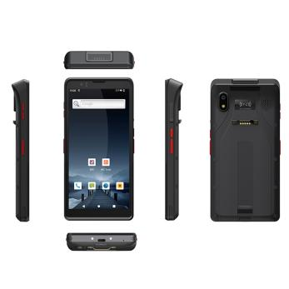

System Configuration

Processor | Octa-core 2.0GHz high-performance processor
O.S | Android12.0
Memory | 32GB ROM+3GB RAM(4GB RAM+64GB ROM optional)
Ex-Storage | Micro SD (Up to 128GB)
Display | 6inch IPS 1440x720 High Resolution
Camera | Front:5.0M Pixels Auto-Focus with LED  flash light  Rear: SONY IMX135 13.0M Pixels autofocus with LED flash light
Touch Panel | Industrial-grade capacitive touch panel
Keypad | Onepower key+one scan key+one volume key+custom key
Notification | Vibrator/LED/Speaker
Battery | 3.7v 5000mAh rechargeable lithium polymer battery
Audio | Built-in microphone/Speaker
Sensor | G-sensor
Interface | Type-C interface, support PE 5.0V and 9.0V fast charging
Structural Parameters
Dimensions  (L xW xD) | 164mm×81mm×20mm
Weight | 290g (battery included)
Communication Transmission
Mobile Network | 3G： WCDMA: B1/B5/B8  CDMA/EVDO 800MHz  GSM: 850/900/1800/1900MHz B2/B3/B5/B8  4G：LTE-FDD:B1/B3/B5/B7/B8/B20  LTE-TDD:B34/B38/B39/B40/B41
Wi-Fi | Wi-Fi 802.11a/b/g/n/r/ac (2.4G+5G dual-band Wi-Fi)
Bluetooth | Bluetooth 5.0, supports BLE
GPS | GPS/AGPS/Beidou/Galileo/GLONASS/QZSS
NFC/HF RFID
Protocol | ISO14443A/14443B/15693
Frequency | 13.56MHz
NFC type | NXP557
Operating Environment
Develop Tools | Android SDK + JDK + Eclipse
P-Language | Java
Operating Temp. | -10°~ 50°C
Storage Temp. | -20°~ 70°C
Humidity | 0 ~ 95% (non-condensing)
Sealing | IP67
1D Laser Scanner
Speed | 100 lines/sec
Scan Angle | ±50°
Identification accuracy | ≥4mil
Decoding Type | UPC-A，UPC-E，UPC-E1，EAN-13，EAN-8，ISBN/ISSN，Code 39，code39 (ASCII full)， Interleaved 2 of 5，Industrial 2 of 5,Matrix 25,Codebar(NW7)，Code 128，UCC/EAN 128，ISBT128，code 93，MSI/Plessey，UK/Plessey，China post，GS1 Data Bar
2D Image Scanner
Method | CMOS Image
Scan Speed | 60scans/sec
Scan Angle | 360 ° angle, Elevation angle ± 55 °, Eeflection angle ± 55 °
Identification accuracy | 2D≥7.5mil，1D≥5mil
Decoding Type | QR Code, Data Matrix, PDF417，UPC-A, UPC-E, EAN-8, EAN-13, ISBN, Code 128, GS1 128, ISBT 128, Code 39, Code93,Code 11, Interleaved 2 of 5, Industrial 2 of 5,Matrix 25, Standard 25, Coda bar, MSI/MSI PLESSEY, GS1 Data Bar
DPM | Support DPM scanner (optional)
Accessories
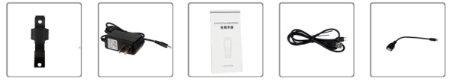

Hand Strap Adapter Manual type c cable OTG cable

